CDC released consolidated, [evidence-based guidance](https://www.cdc.gov/orr/school-preparedness/infection-prevention/index.html) for preventing the spread of infections in K-12 schools. The guidance includes everyday actions that schools can take to prevent and control the spread of respiratory and stomach viruses and illnesses, such as influenza and norovirus, and bacterial illness, such as strep throat. This guidance is designed to maximize school attendance and its benefits for all students, while also preventing the spread of infectious diseases. Being in school provides many benefits including ongoing learning and social and emotional development.

The strategies found in the new guidance are based on research and expertise CDC gained from decades of working to prevent disease transmission in school settings. They include:

* Teach and reinforce proper hand washing and respiratory etiquette.
* Take steps for cleaner air by improving ventilation in schools. Schools should consider ventilation enhancements and design when undergoing remodeling or when undertaking new building construction to optimize clean air.
* Clean, sanitize, and disinfect when appropriate.
* Promote vaccinations for students and staff.

When children or staff do become ill, there are additional strategies schools can implement to help slow the spread of infectious diseases including:

* Have staff and students stay home when they are sick. The guidance makes clear what specific symptoms necessitate staying home.
* When applicable, use personal protective equipment (PPE) for school staff who are caring for sick children.
* Hand washing, respiratory etiquette, cleaning, sanitizing, and disinfecting remain important.

When there is a higher level of illness in the school community, schools can add other strategies to their regular activities in addition to increasing everyday actions like hand washing and ventilation. Which strategies, and how many, are added can be based on considerations such as local factors (for example, elevated absenteeism in your area, community preferences) and the virus or other pathogen that is circulating.

The new guidance also recommends updating or developing emergency operation plans that include infectious disease sections, and establishing and maintaining key partnerships with health departments, local medical systems, and other community health providers.

Key resources:

* [Guidance for Prevention the Spread of Infections in K-12 Schools](https://www.cdc.gov/orr/school-preparedness/infection-prevention/index.html)
* [Science Brief: Prevention and Control of Respiratory and Gastrointestinal Infections in Kindergarten through Grade 12 (K-12) Schools](https://www.cdc.gov/orr/school-preparedness/infection-prevention/docs/IPC-Science-Brief_508.pdf)
* [CDC Respiratory Virus Guidance](https://www.cdc.gov/respiratory-viruses/guidance/respiratory-virus-guidance.html)

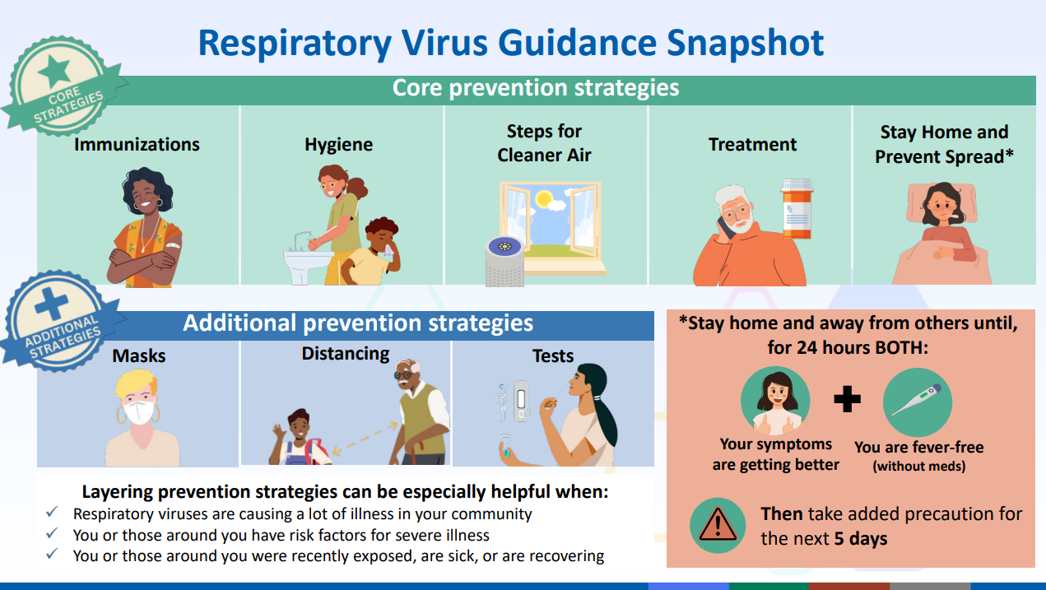

Example 1: Person with fever and symptoms.

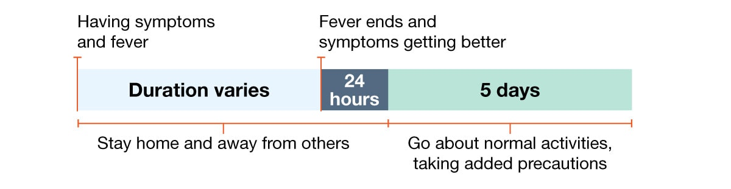

Example 2: Person with fever but no other symptoms.

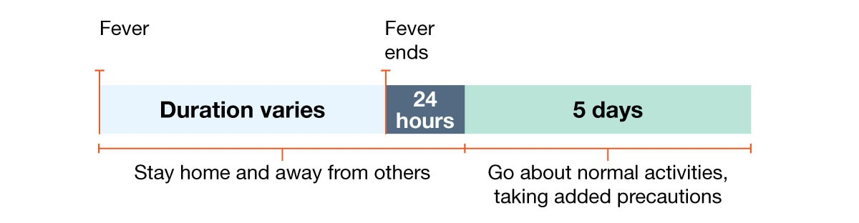

Example 3: Person with fever and other symptoms, fever ends but other symptoms take longer to improve.

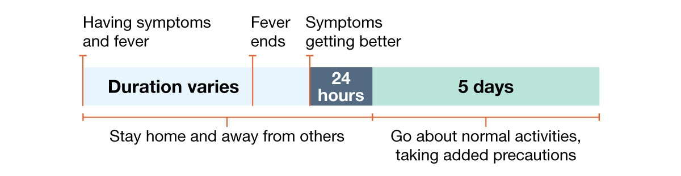

Example 4: Person gets better and then gets a fever.

